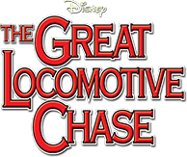

- Why do you think the story of Andrews’ Raiders would be appealing to children in 1950s America?

- This movie and The General tell the same story—albeit in separate ways. How are the movies similar yet different?

- What elements of the movie could be considered corny by today’s standards?

- Who were you rooting for—the chased or the chasers? Why?

- How does the film’s use of practical effects and authentic settings aid the storyline?

- In what ways does the movie evoke Disney’s desire to tell tales of patriotism?

- How does the film eventually revisit the recurring theme of reconciliation?

- Does The Great Locomotive Chase do the true story justice?

- How is the ending of this movie different from the typical Disney film?

- Why do you think Disney does not really make historical movies for kids anymore?

Subscribe and view additional content on our YouTube channel.

