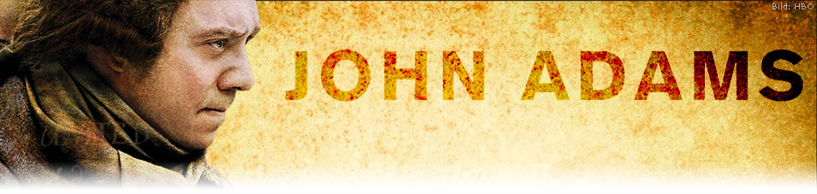

- What have you heard about the “Boston Massacre” before this class? How does the film’s opening depiction of it compare and contrast with what you knew?

- From what you have seen in the video, how might you characterize the Sons of Liberty? Please cite evidence to support your answer.

- Describe the look and feel of 18th century Boston. What traits of colonial life can you find within this recreated setting?

- What role did Abigail Adams play to her husband? Please provide evidence to support your answer.

- After John Adams defended the redcoats, was his reputation hurt or helped? Please give evidence to support your answer.

- Have you ever done anything unpopular even though you knew it was the right thing to do? If so, feel free to elaborate.

- Several cases of violence are enacted in the film. Which did you find the most unsettling? When is it justified—if ever—to enact violence?

- Where does John Adams depart for at the end and why?

Subscribe and view additional content on our YouTube channel.

Accompanying primary sources:

Deposition of Captain Thomas Preston, March 12, 1770
...I saw the people in great commotion and heard them use the most cruel and horrid threats against the troops. They immediately surrounded the sentry...and with clubs and other weapons threatened to execute their vengeance on him. I was soon informed by a townsman their intention was to carry off the soldier from his post and probably murder him.... I immediately sent a non-commissioned officer and 12 men to protect both the sentry and the king's money, and very soon followed myself to prevent, if possible, all disorder... They soon rushed through the people, and by charging their bayonets in half-circles, kept them at a little distance. ... The mob still increased and were more outrageous, striking their clubs or bludgeons one against another, and calling out, “come on you rascals, you bloody backs, you lobster scoundrels, fire if you dare, G-d damn you, fire and be damned, we know you dare not,” and much more such language was used.
At this time I was between the soldiers and the mob, parleying with, and endeavouring all in my power to persuade them to retire peaceably, but to no purpose....The whole of this melancholy affair was transacted in almost 20 minutes. On my asking the soldiers why they fired without orders, they said they heard the word fire and supposed it came from me. This might be the case as many of the mob called out fire, fire, but I assured the men that I gave no such order; that my words were, don't fire, stop your firing. In short, it was scarcely possible for the soldiers to know who said fire, or don't fire, or stop your firing...

Boston Gazette and Country Journal
Monday March 12, 1770,
...Thirty or forty persons, mostly lads, being by this means gathered in King Street, Capt. Preston with a party of men with charged bayonets, came from the main guard to the commissioner's house, the soldiers pushing their bayonets, crying, make way! They took place by the custom house and, continuing to push to drive the people off pricked some in several places, on which they were clamorous and, it is said, threw snow balls. On this, the Captain commanded them to fire; and more snow balls coming, he again said, damn you, fire, be the consequence what it will! One soldier then fired, and a townsman with a cudgel struck him over the hands with such force that he dropped his firelock; and, rushing forward, aimed a blow at the Captain's head which grazed his hat and fell pretty heavy upon his arm. However, the soldiers continued the fire successively till seven or eight or, as some say, eleven guns were discharged.

