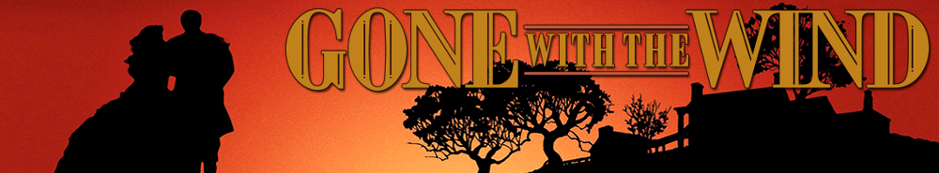

- Pay special note to the opening. What does the filmmaker wish to convey about the setting with the opening music, backgrounds, and introduction?

- Interpret the symbolism of the plantation named Tara. What does it represent to the characters? What might have it have represented to 1939 audiences?

- Analyze the character of Mammy—the O’Hara family’s maid slave. Is she a figure of authority or submission?
- Describe the appeal of the character Rhett Butler (played by Clark Gable).

- How is the significance of the Battle of Gettysburg underscored in the film? How does this scene stress the idea of that battle as a turning point of the war?

- Describe how the character of Prissy is depicted as childlike. How could such a portrayal be considered harmful?

- The Atlanta hospital scene beginning around the 1:15:00 mark is one of the most iconic in cinema. What makes it so compelling?

- Is Scarlet O’Hara a hero or brat? How do you think her character’s trajectory was meant to be symbolic of women who endured the Civil War?

- Identify three themes of the film that you think resonated with Depression era audiences of the 1930s. Think particularly of the last few minutes we watch.
- Explain Gone with the Wind is a perfect cinematic representation of the “Lost Cause.”

Subscribe and view additional content on our YouTube channel.
Accompanying primary sources:
(1) Orders issued by William Sherman before his March to the Sea (9th November 1864)
The army will forage liberally on the country during the march. To this end, each brigade commander will organize a good and sufficient foraging party, under the command of one or more discreet officers, who will gather, near the route traveled, corn or forage of any kind, meat of any kind, vegetables, corn-meal, or whatever is needed by the command, aiming at all times to keep in the wagons at least ten days' provisions for his command, aiming at all times to keep in the wagons at least ten days' provisions for his command, and three days' forage. Soldiers must not enter the dwellings they may be permitted to gather turnips, potatoes, and other vegetables, and to drive in stock in sight of their camp.
To corps commanders alone is entrusted the power to destroy mills, houses, cotton-gins, etc.; and for them the general principle is laid down: In districts and neighborhoods where the army is unmolested, no destruction of such property should be permitted; but should guerrillas or bush-whackers molest our march, or should the inhabitants burn bridges, obstruct roads, or otherwise manifest local hostility, then army commanders should order and enforce a devastation more or less relentless, according to the measure of such hostility. As for horses, mules, wagons, etc., belonging to the inhabitants, the cavalry and artillery may appropriate freely and without limit; discriminating, however, between the rich, who are usually hostile, and the poor and industrious, usually neutral or friendly.

(2) William Sherman wrote about his Atlanta Campaign in his Memoirs published in 1875.
The skill and success of the men in collecting forage was one of the features of this march. Each brigade commander had authority to detail a company of foragers, usually about fifty men, with one or two commissioned officers selected for their boldness and enterprise. This party would be dispatched before daylight with a knowledge of the intended day's march and camp; would proceed on foot five or six miles from the route traveled by their brigade, and then visit every plantation and farm within range. They would usually procure a wagon or family carriage, load it with bacon, corn-meal, turkeys, chickens, ducks, and every thing that could be used as food or forage, and would then regain the main road, usually in advance of their train. No doubt, many acts of pillage, robbery, and violence, were committed by these parties of foragers, for I have since heard of jewelry taken from women, and the plunder of articles that never reached the commissary; but these acts were exceptional and incidental. I never heard of any cases of murder or rape; and no army could have carried along sufficient food and forage for a march of three hundred miles; so that foraging in some shape was necessary.

(3) Statement issued by the members of the Georgia Congress (19th November 1864)
We have had a special conference with President Davis and the Secretary of War, and are able to assure you that they have done and are still doing all that can be done to meet the emergency that presses upon you. Let every man fly to arms! Remove your negroes, horses, cattle, and provisions from Sherman's army, and burn what you cannot carry. Burn all bridges, and block up the roads in his route. Assail the invader in front, flank, and rear, by night and by day. Let him have no rest.

