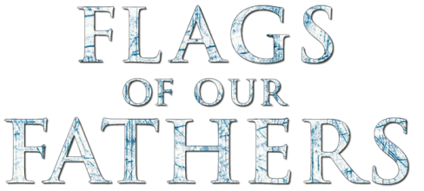

- What was the strategic importance of the island of Iwo Jima? Why did the U. S. want it?

- Why do you think the Japanese fought so relentlessly against the Americans?

- Why or why not did the Iwo Jima veterans feel their sacrifices were worthwhile?

- Why did the American people have such an emotional response to Joe Rosenthal’s photo?

- Why was it important for the surviving flag raisers to stress that the real heroes were the young Marines who died on the battlefield?

- How was the flag raising photo an important piece of propaganda for the U. S. government? Why was it important for the families of the deceased veterans?

- What was the purpose of the War Bonds campaign? What were the risks if it failed?

- What is the relationship between being a hero and being a celebrity?

- Wars are fought by people your age. How were you able to relate to the film’s characters?

- Heroism comes in many forms. What is the most heroic thing you have seen in person?

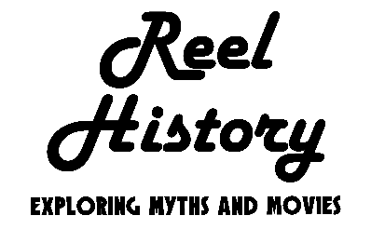
Subscribe and view additional content on our YouTube channel.

Accompanying Primary Source from Richmond, Virginia’s The Times Dispatch – June 27, 1945, page 5:
